326010020036
Soumyabrata Misra
Basic of Web Development
2026
Online BCA

Program Screen 1:
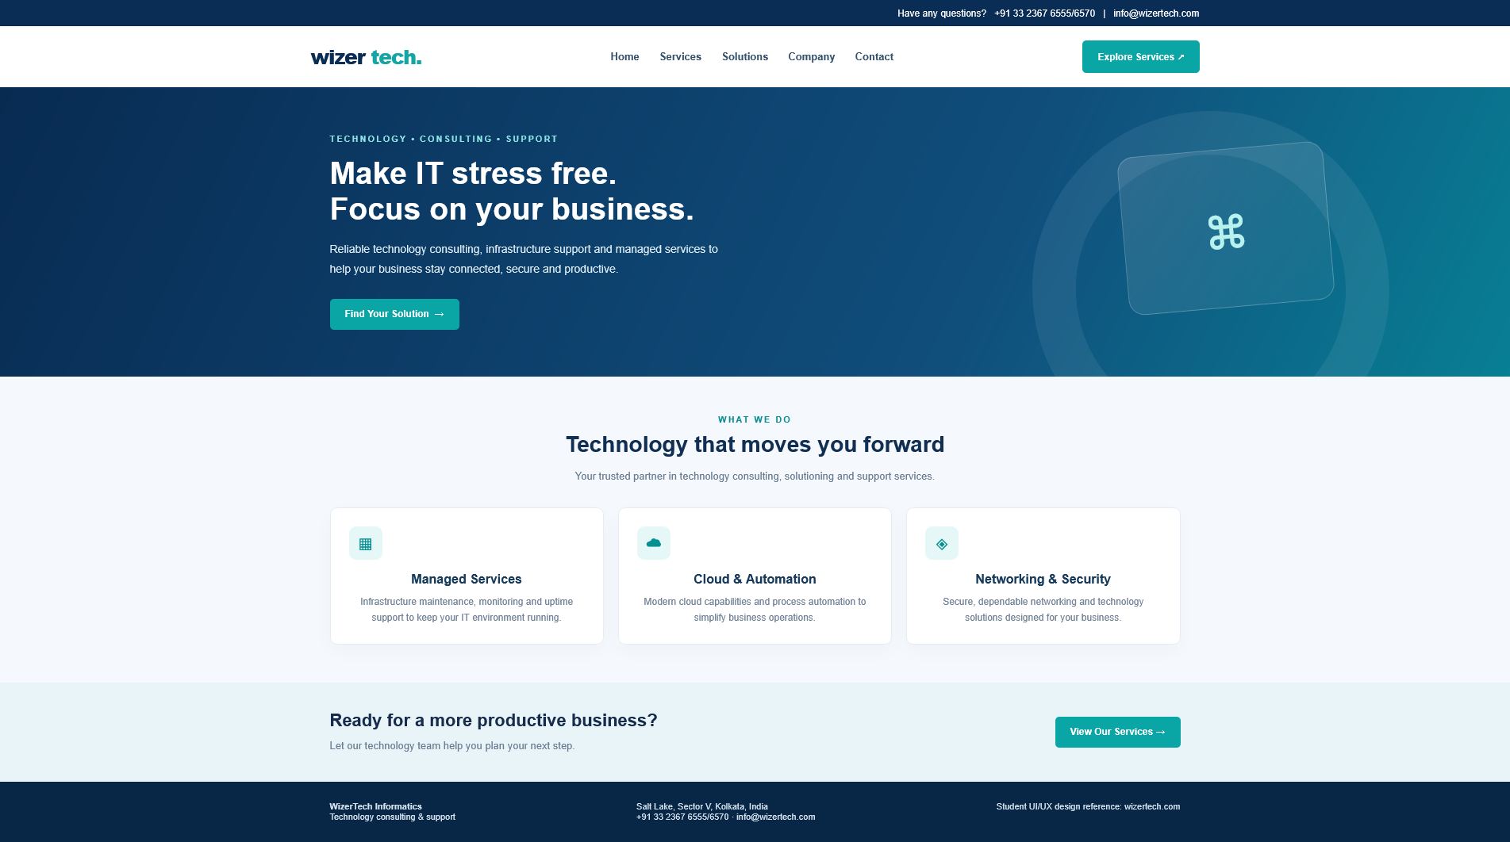

Program 1 HTML: (index.html)
<!DOCTYPE html>
<html lang="en">
<head>
<meta charset="UTF-8">
<meta name="viewport" content="width=device-width, initial-scale=1.0">
<title>
WizerTech | Technology Services
</title>
<link rel="stylesheet" href="style.css">
</head>
<body>
<div class="top">
Have any questions? &nbsp; +91 33 2367 6555/6570 &nbsp; | &nbsp; info@wizertech.com
</div>
<nav class="nav">
<div class="brand">
wizer
<span>
tech.
</span>
</div>
<div class="links">
<a href="index.html">
Home
</a>
<a href="services.html">
Services
</a>
<a href="services.html">
Solutions
</a>
<a href="#company">
Company
</a>
<a href="#contact">
Contact
</a>
</div>
<a class="btn" href="services.html">
Explore Services ↗
</a>
</nav>
<header class="hero">
<div class="hero-inner">
<div class="eyebrow">
Technology • Consulting • Support
</div>
<h1>
Make IT stress free.
<br>
Focus on your business.
</h1>
<p>
Reliable technology consulting, infrastructure support and managed services to help your business stay connected, secure and productive.
</p>
<a class="btn" href="services.html">
Find Your Solution&nbsp; →
</a>
</div>
<div class="hero-art">
⌘
</div>
</header>
<main>
<section class="section" id="company">
<div class="wrap center">
<div class="eyebrow" style="color:#078f91">
WHAT WE DO
</div>
<h2>
Technology that moves you forward
</h2>
<p class="muted">
Your trusted partner in technology consulting, solutioning and support services.
</p>
<div class="cards">
<article class="card">
<div class="ico">
▦
</div>
<h3>
Managed Services
</h3>
<p>
Infrastructure maintenance, monitoring and uptime support to keep your IT environment running.
</p>
</article>
<article class="card">
<div class="ico">
☁
</div>
<h3>
Cloud & Automation
</h3>
<p>
Modern cloud capabilities and process automation to simplify business operations.
</p>
</article>
<article class="card">
<div class="ico">
◈
</div>
<h3>
Networking & Security
</h3>
<p>
Secure, dependable networking and technology solutions designed for your business.
</p>
</article>
</div>
</div>
</section>
<section class="band">
<div class="wrap bandin">
<div>
<h2>
Ready for a more productive business?
</h2>
<div class="muted">
Let our technology team help you plan your next step.
</div>
</div>
<a class="btn" href="services.html">
View Our Services →
</a>
</div>
</section>
</main>
<footer class="footer" id="contact">
<div class="wrap footin">
<div>
<b>
WizerTech Informatics
</b>
<br>
Technology consulting & support
</div>
<div>
Salt Lake, Sector V, Kolkata, India
<br>
+91 33 2367 6555/6570 · info@wizertech.com
</div>
<div>
Student UI/UX design reference: wizertech.com
</div>
</div>
</footer>
</body>
</html>

Program 1 CSS:
/* ===== Common Styles for Both Screens ===== */

* {
box-sizing:border-box;
}body {
margin:0;
font-family:Arial,Helvetica,sans-serif;
color:#172b4d;
background:#f5f8fc;
}a {
text-decoration:none;
color:inherit;
}.top {
background:#092d55;
color:#fff;
padding:9px max(calc((100% - 1120px)/2),24px);
font-size:12px;
text-align:right;
}.nav {
background:#fff;
display:flex;
align-items:center;
justify-content:space-between;
padding:18px max(calc((100% - 1120px)/2),24px);
box-shadow:0 2px 10px #0a2a5010;
gap:24px;
}.brand {
font-size:25px;
font-weight:800;
color:#092d55;
letter-spacing:-1px;
}.brand span {
color:#14a5a5;
}.links {
display:flex;
gap:25px;
font-size:13px;
font-weight:700;
color:#34516d;
}.btn {
background:#0aa6a6;
color:#fff;
padding:12px 19px;
border-radius:5px;
font-size:12px;
font-weight:700;
display:inline-block;
}.wrap {
max-width:1120px;
margin:auto;
padding:0 24px;
}.hero {
background:linear-gradient(115deg,#082b52 0%,#104e7c 65%,#087f94 100%);
color:white;
min-height:365px;
display:flex;
align-items:center;
overflow:hidden;
position:relative;
}.hero:after {
content:'';
position:absolute;
width:340px;
height:340px;
border:55px solid #ffffff12;
border-radius:50%;
right:8%;
top:30px;
}.hero-inner {
max-width:1120px;
width:100%;
margin:auto;
padding:55px 24px;
position:relative;
z-index:1;
}.eyebrow {
font-size:11px;
text-transform:uppercase;
letter-spacing:2px;
color:#8ce4e2;
font-weight:700;
}.hero h1 {
font-size:39px;
line-height:1.15;
max-width:570px;
margin:15px 0;
}.hero p {
font-size:14px;
line-height:1.8;
color:#dcebf5;
max-width:510px;
margin-bottom:25px;
}.hero-art {
position:absolute;
right:12%;
top:78px;
width:260px;
height:200px;
z-index:1;
border:1px solid #ffffff3b;
border-radius:20px;
background:linear-gradient(135deg,#ffffff20,#ffffff08);
transform:rotate(-5deg);
display:flex;
align-items:center;
justify-content:center;
font-size:74px;
color:#b8f2ef;
}.section {
padding:48px 0;
}.center {
text-align:center;
}.section h2 {
font-size:28px;
margin:9px 0 10px;
color:#102f52;
}.muted {
color:#6a7e93;
font-size:13px;
line-height:1.7;
}.cards {
display:grid;
grid-template-columns:repeat(3,1fr);
gap:18px;
margin-top:28px;
}.card {
background:#fff;
border:1px solid #e5edf4;
border-radius:9px;
padding:23px;
box-shadow:0 8px 24px #163b5b08;
}.ico {
width:42px;
height:42px;
border-radius:9px;
background:#e5f8f7;
color:#078f91;
display:flex;
align-items:center;
justify-content:center;
font-size:21px;
margin-bottom:16px;
}.card h3 {
font-size:16px;
margin:0 0 9px;
color:#163b5d;
}.card p {
font-size:12px;
line-height:1.7;
color:#718398;
margin:0;
}.band {
background:#e9f4f8;
padding:34px 0;
}.bandin {
display:flex;
justify-content:space-between;
align-items:center;
gap:20px;
}.band h2 {
font-size:22px;
margin:0 0 8px;
}.footer {
background:#082746;
color:#d3e2ee;
padding:25px 0;
font-size:11px;
}.footin {
display:flex;
justify-content:space-between;
gap:20px;
}.pagehead {
background:linear-gradient(110deg,#092d55,#116b87);
color:white;
padding:52px 0;
}.pagehead h1 {
font-size:34px;
margin:8px 0;
}.crumb {
font-size:11px;
color:#a7d9e2;
}.service-layout {
display:grid;
grid-template-columns:1.1fr 2fr;
gap:30px;
align-items:start;
}.side {
background:#fff;
border:1px solid #e3ebf2;
border-radius:9px;
padding:20px;
}.side h3 {
font-size:15px;
margin:0 0 13px;
}.side a {
display:block;
padding:11px 8px;
border-bottom:1px solid #edf1f5;
font-size:12px;
color:#48627a;
}.side a.active {
color:#078e91;
font-weight:bold;
background:#effafa;
}.service-grid {
display:grid;
grid-template-columns:repeat(2,1fr);
gap:16px;
}.service-grid .card {
min-height:155px;
}.service-grid h3 {
font-size:15px;
}.tag {
display:inline-block;
background:#e7f7f7;
color:#087f85;
padding:5px 8px;
border-radius:3px;
font-size:10px;
font-weight:bold;
margin-top:13px;
}

@media(max-width:700px){.links {
display:none;
}.hero h1 {
font-size:30px;
}.hero-art {
opacity:.25;
right:-30px;
}.cards,.service-layout {
grid-template-columns:1fr;
}.service-grid {
grid-template-columns:1fr;
}.bandin,.footin {
display:block;
}.top {
text-align:center;
}}

Program 1 JS:
This screen uses no JavaScript; the design is built entirely with HTML5 and CSS3.

Program Screen 2: (services.html)
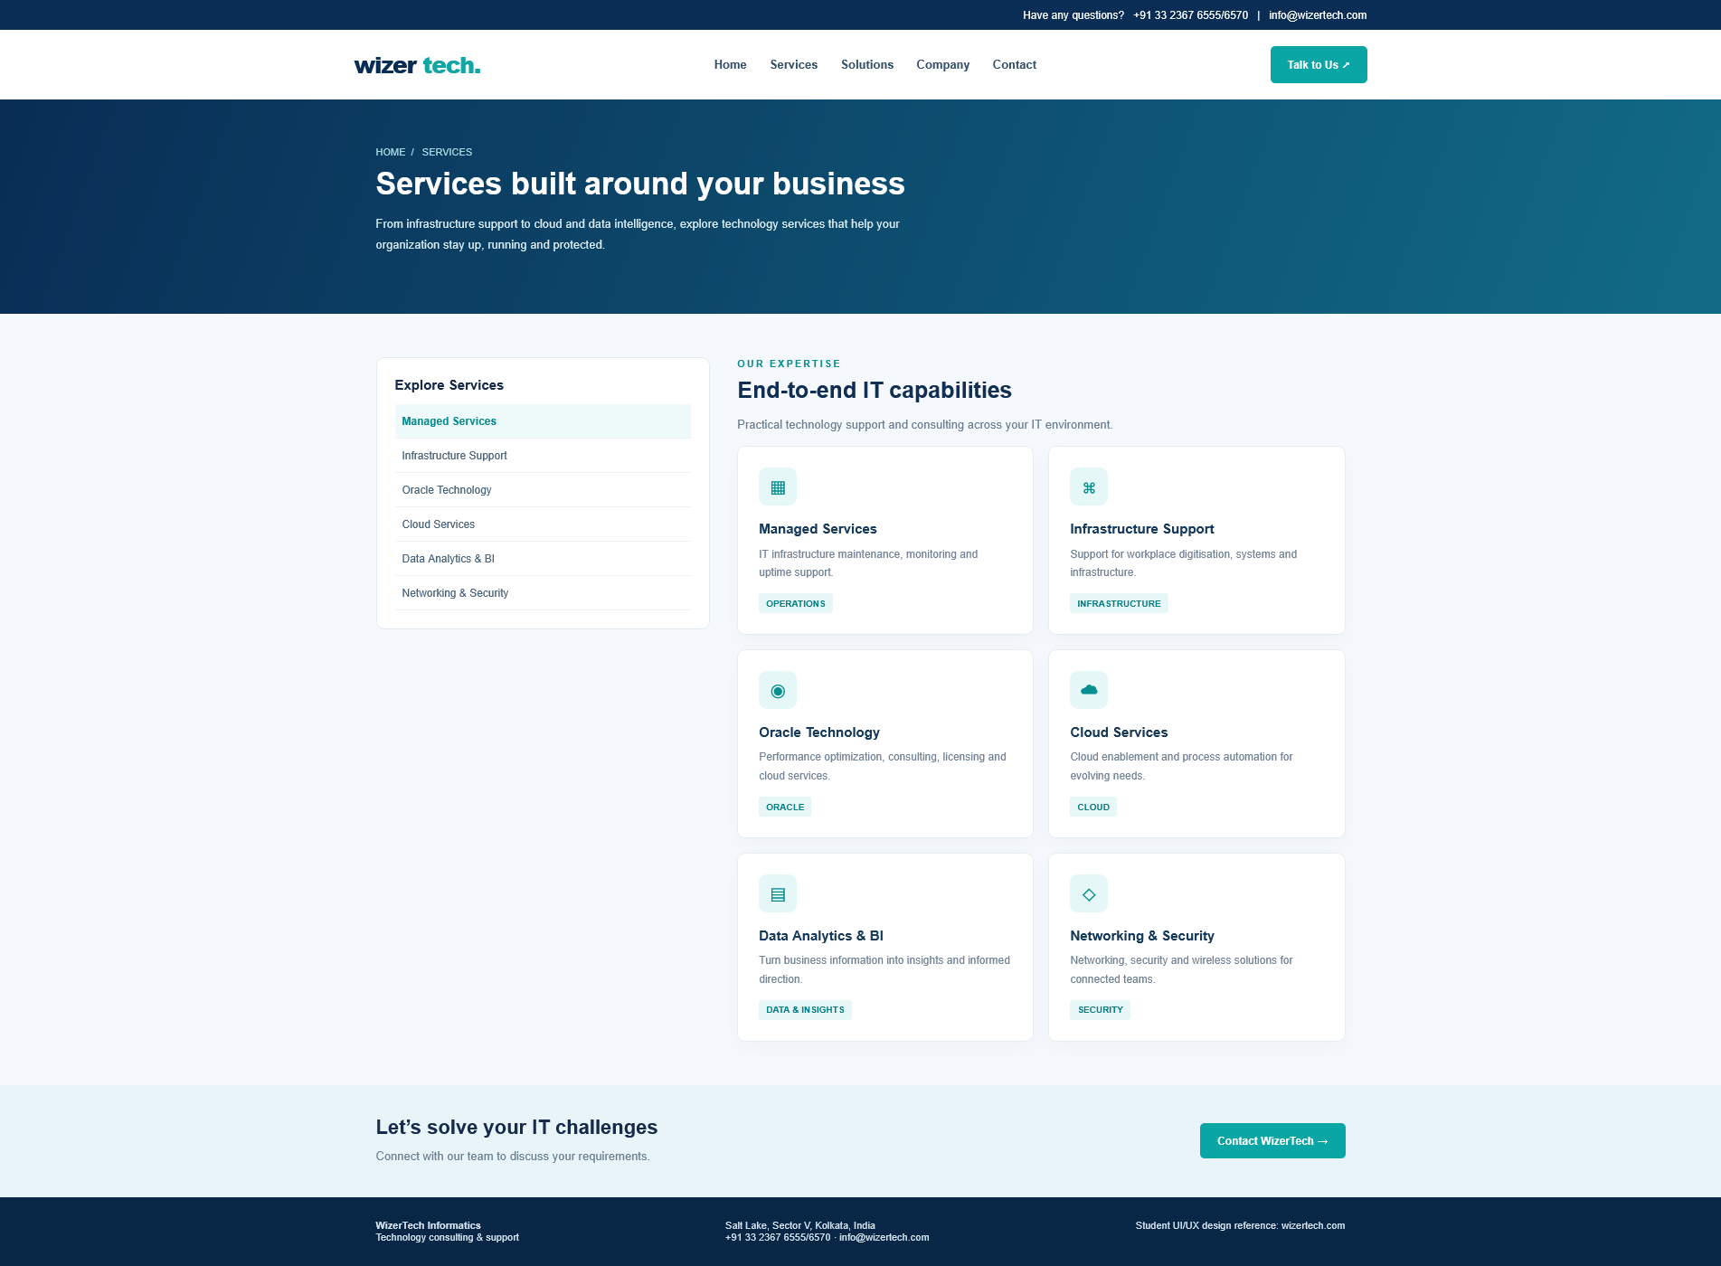

Program 2 HTML: (services.html)
<!DOCTYPE html>
<html lang="en">
<head>
<meta charset="UTF-8">
<meta name="viewport" content="width=device-width, initial-scale=1.0">
<title>
Our Services | WizerTech
</title>
<link rel="stylesheet" href="style.css">
</head>
<body>
<div class="top">
Have any questions? &nbsp; +91 33 2367 6555/6570 &nbsp; | &nbsp; info@wizertech.com
</div>
<nav class="nav">
<div class="brand">
wizer
<span>
tech.
</span>
</div>
<div class="links">
<a href="index.html">
Home
</a>
<a href="services.html">
Services
</a>
<a href="services.html">
Solutions
</a>
<a href="index.html#company">
Company
</a>
<a href="#contact">
Contact
</a>
</div>
<a class="btn" href="#contact">
Talk to Us ↗
</a>
</nav>
<header class="pagehead">
<div class="wrap">
<div class="crumb">
HOME&nbsp; / &nbsp; SERVICES
</div>
<h1>
Services built around your business
</h1>
<p style="color:#d8eaf2;font-size:13px;max-width:620px;line-height:1.8">
From infrastructure support to cloud and data intelligence, explore technology services that help your organization stay up, running and protected.
</p>
</div>
</header>
<main class="section">
<div class="wrap service-layout">
<aside class="side">
<h3>
Explore Services
</h3>
<a class="active" href="#managed">
Managed Services
</a>
<a href="#infra">
Infrastructure Support
</a>
<a href="#oracle">
Oracle Technology
</a>
<a href="#cloud">
Cloud Services
</a>
<a href="#analytics">
Data Analytics & BI
</a>
<a href="#security">
Networking & Security
</a>
</aside>
<div>
<div class="eyebrow" style="color:#078f91">
OUR EXPERTISE
</div>
<h2 style="font-size:25px;margin-top:8px">
End-to-end IT capabilities
</h2>
<p class="muted">
Practical technology support and consulting across your IT environment.
</p>
<div class="service-grid">
<article class="card" id="managed">
<div class="ico">
▦
</div>
<h3>
Managed Services
</h3>
<p>
IT infrastructure maintenance, monitoring and uptime support.
</p>
<span class="tag">
OPERATIONS
</span>
</article>
<article class="card" id="infra">
<div class="ico">
⌘
</div>
<h3>
Infrastructure Support
</h3>
<p>
Support for workplace digitisation, systems and infrastructure.
</p>
<span class="tag">
INFRASTRUCTURE
</span>
</article>
<article class="card" id="oracle">
<div class="ico">
◉
</div>
<h3>
Oracle Technology
</h3>
<p>
Performance optimization, consulting, licensing and cloud services.
</p>
<span class="tag">
ORACLE
</span>
</article>
<article class="card" id="cloud">
<div class="ico">
☁
</div>
<h3>
Cloud Services
</h3>
<p>
Cloud enablement and process automation for evolving needs.
</p>
<span class="tag">
CLOUD
</span>
</article>
<article class="card" id="analytics">
<div class="ico">
▤
</div>
<h3>
Data Analytics & BI
</h3>
<p>
Turn business information into insights and informed direction.
</p>
<span class="tag">
DATA & INSIGHTS
</span>
</article>
<article class="card" id="security">
<div class="ico">
◇
</div>
<h3>
Networking & Security
</h3>
<p>
Networking, security and wireless solutions for connected teams.
</p>
<span class="tag">
SECURITY
</span>
</article>
</div>
</div>
</div>
</main>
<section class="band">
<div class="wrap bandin">
<div>
<h2>
Let’s solve your IT challenges
</h2>
<div class="muted">
Connect with our team to discuss your requirements.
</div>
</div>
<a class="btn" href="mailto:info@wizertech.com">
Contact WizerTech →
</a>
</div>
</section>
<footer class="footer" id="contact">
<div class="wrap footin">
<div>
<b>
WizerTech Informatics
</b>
<br>
Technology consulting & support
</div>
<div>
Salt Lake, Sector V, Kolkata, India
<br>
+91 33 2367 6555/6570 · info@wizertech.com
</div>
<div>
Student UI/UX design reference: wizertech.com
</div>
</div>
</footer>
</body>
</html>

Program 2 CSS: (style.css)
/* ===== Common Styles for Both Screens ===== */

* {
box-sizing:border-box;
}body {
margin:0;
font-family:Arial,Helvetica,sans-serif;
color:#172b4d;
background:#f5f8fc;
}a {
text-decoration:none;
color:inherit;
}.top {
background:#092d55;
color:#fff;
padding:9px max(calc((100% - 1120px)/2),24px);
font-size:12px;
text-align:right;
}.nav {
background:#fff;
display:flex;
align-items:center;
justify-content:space-between;
padding:18px max(calc((100% - 1120px)/2),24px);
box-shadow:0 2px 10px #0a2a5010;
gap:24px;
}.brand {
font-size:25px;
font-weight:800;
color:#092d55;
letter-spacing:-1px;
}.brand span {
color:#14a5a5;
}.links {
display:flex;
gap:25px;
font-size:13px;
font-weight:700;
color:#34516d;
}.btn {
background:#0aa6a6;
color:#fff;
padding:12px 19px;
border-radius:5px;
font-size:12px;
font-weight:700;
display:inline-block;
}.wrap {
max-width:1120px;
margin:auto;
padding:0 24px;
}.hero {
background:linear-gradient(115deg,#082b52 0%,#104e7c 65%,#087f94 100%);
color:white;
min-height:365px;
display:flex;
align-items:center;
overflow:hidden;
position:relative;
}.hero:after {
content:'';
position:absolute;
width:340px;
height:340px;
border:55px solid #ffffff12;
border-radius:50%;
right:8%;
top:30px;
}.hero-inner {
max-width:1120px;
width:100%;
margin:auto;
padding:55px 24px;
position:relative;
z-index:1;
}.eyebrow {
font-size:11px;
text-transform:uppercase;
letter-spacing:2px;
color:#8ce4e2;
font-weight:700;
}.hero h1 {
font-size:39px;
line-height:1.15;
max-width:570px;
margin:15px 0;
}.hero p {
font-size:14px;
line-height:1.8;
color:#dcebf5;
max-width:510px;
margin-bottom:25px;
}.hero-art {
position:absolute;
right:12%;
top:78px;
width:260px;
height:200px;
z-index:1;
border:1px solid #ffffff3b;
border-radius:20px;
background:linear-gradient(135deg,#ffffff20,#ffffff08);
transform:rotate(-5deg);
display:flex;
align-items:center;
justify-content:center;
font-size:74px;
color:#b8f2ef;
}.section {
padding:48px 0;
}.center {
text-align:center;
}.section h2 {
font-size:28px;
margin:9px 0 10px;
color:#102f52;
}.muted {
color:#6a7e93;
font-size:13px;
line-height:1.7;
}.cards {
display:grid;
grid-template-columns:repeat(3,1fr);
gap:18px;
margin-top:28px;
}.card {
background:#fff;
border:1px solid #e5edf4;
border-radius:9px;
padding:23px;
box-shadow:0 8px 24px #163b5b08;
}.ico {
width:42px;
height:42px;
border-radius:9px;
background:#e5f8f7;
color:#078f91;
display:flex;
align-items:center;
justify-content:center;
font-size:21px;
margin-bottom:16px;
}.card h3 {
font-size:16px;
margin:0 0 9px;
color:#163b5d;
}.card p {
font-size:12px;
line-height:1.7;
color:#718398;
margin:0;
}.band {
background:#e9f4f8;
padding:34px 0;
}.bandin {
display:flex;
justify-content:space-between;
align-items:center;
gap:20px;
}.band h2 {
font-size:22px;
margin:0 0 8px;
}.footer {
background:#082746;
color:#d3e2ee;
padding:25px 0;
font-size:11px;
}.footin {
display:flex;
justify-content:space-between;
gap:20px;
}.pagehead {
background:linear-gradient(110deg,#092d55,#116b87);
color:white;
padding:52px 0;
}.pagehead h1 {
font-size:34px;
margin:8px 0;
}.crumb {
font-size:11px;
color:#a7d9e2;
}.service-layout {
display:grid;
grid-template-columns:1.1fr 2fr;
gap:30px;
align-items:start;
}.side {
background:#fff;
border:1px solid #e3ebf2;
border-radius:9px;
padding:20px;
}.side h3 {
font-size:15px;
margin:0 0 13px;
}.side a {
display:block;
padding:11px 8px;
border-bottom:1px solid #edf1f5;
font-size:12px;
color:#48627a;
}.side a.active {
color:#078e91;
font-weight:bold;
background:#effafa;
}.service-grid {
display:grid;
grid-template-columns:repeat(2,1fr);
gap:16px;
}.service-grid .card {
min-height:155px;
}.service-grid h3 {
font-size:15px;
}.tag {
display:inline-block;
background:#e7f7f7;
color:#087f85;
padding:5px 8px;
border-radius:3px;
font-size:10px;
font-weight:bold;
margin-top:13px;
}

@media(max-width:700px){.links {
display:none;
}.hero h1 {
font-size:30px;
}.hero-art {
opacity:.25;
right:-30px;
}.cards,.service-layout {
grid-template-columns:1fr;
}.service-grid {
grid-template-columns:1fr;
}.bandin,.footin {
display:block;
}.top {
text-align:center;
}}

Program 2 JS:
This screen uses no JavaScript; the design is built entirely with HTML5 and CSS3.

